Alyssa Kelley

Comp3700

Homework 4

1. Medical information should always be organized and guarded but easily accessible to the right people. In hospitals there are many different departments who need this information. Sharing is a necessary task that is utilized by all the different departments, but certain information must be kept secure or private when necessary. For example, a doctor may prescribe a specific medicine for a patient and send the prescription to the pharmacy department. The pharmacy needs access to the patients name and prescription. However, it does not need access to the details the patient wants to keep private. The pharmacy, also, cannot be allowed to change this information without the permission of the doctor. Medical Information Management System, or MIMS, is a database that allows all patient information to be orderly and secure but still provides easy communication between departments. Every medical staff member will have his or her own username and password that will give him or her only the information allowed for their department. Each department will have different links to files with the exact information that they need without searching through insignificant data to find it. This allows for more efficiency amongst departments and gives the patients more privacy, allowing only trusted staff to read their information. The files sent to each department cannot be changed by anyone except the original dispatcher. Sent information can only be read. If needed, each department can create their own document that can be later added to the original. MIMS will allow each hospital or doctors office to run more efficiently will minimal effort.

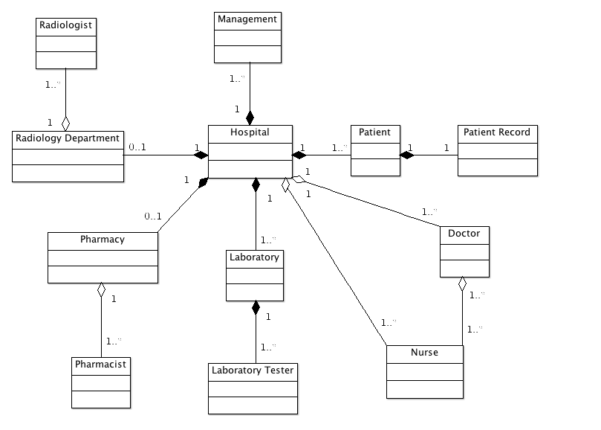

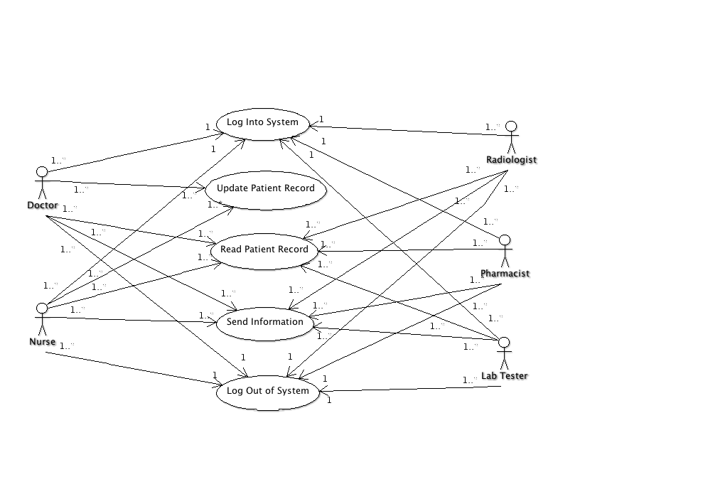

1. Use Cases:   
   Log into the System:

* Any actor enters username and password.
* System validates username and password.
* Actor is logged in.

Update Patient Record

* Nurse or Doctor enters username and password.
* System validates username and password.
* Nurse or Doctor is logged in.
* System provides links.
* Nurse or Doctor chooses patient’s record and writes new information.
* System saves information.

Read Patient Record

* Any actor enters username and password
* System validates username and password
* Actor is logged in.
* System provides links. (Different links per actor type)
* Actor chooses patient’s record and reads.

Send Information

* Any actor enters username and password
* System validates username and password
* Actor is logged in.
* System provides links.
* Actor chooses the send information link and sends information.
* System confirms that the information has been sent.

Log out of System

* Any actor enters username and password
* System validates username and password
* Actor is logged in.
* System provides links.
* Actor may choose to perform an action.
* Actor chooses to log out.
* System confirms log out.

